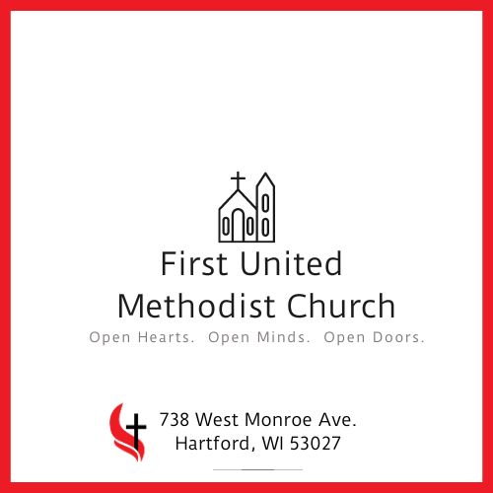

FIRST UNITED METHODIST CHURCH NEWSLETTER DECEMBER 2023

https://www.fumchartford.com/
You Are Invited To Celebrate and Worship
With Us This Christmas Season. All are Welcome!
December 6th - 6pm, our Messy Church theme is PAJAMAS, PIZZA & SANTA! Be sure to wear your cozy pajamas and enjoy a visit with Santa!

December 24th - 9am Advent Worship 4pm Family Worship and 7pm Traditional Worship
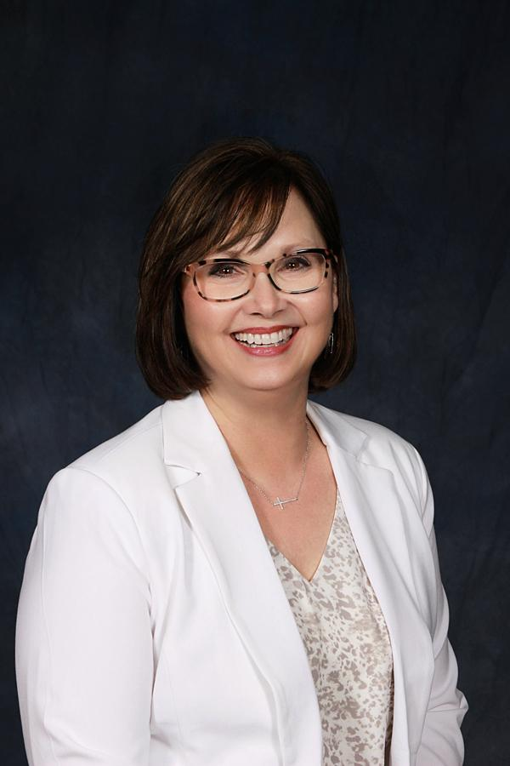Letter from Pastor Cheryl
It’s That Time of Year (the song by Frank Sinatra is playing in my head!) and we are focusing this Advent season on “The Gift of Being Present”. Advent can be filled with worry about finding the perfect Christmas gifts. Deep down we want people in our lives to know they are special and that we love them. But sometimes we overlook the greatest gift of all… our very presence. Our spiritual ancestors were also worried — often about survival in the midst of all that was happening in the Roman world. And the response of the scriptures is “the Holy Living One is with you.” Like a shepherd who never leaves the flock, we are held close. This season, we are invited to be the gift of presence for our loved ones, for our communities, for those who need it most. I hope you’ll join us in worship this Advent and Christmas season.
Wishing you all the hope, peace, love, and joy of the season!
Merry Christmas from Pastor Cheryl and Pastor Mark

Robin is Retiring!
It is with a mix of joy (for her) and sadness (for us) that we announce Robin is stepping back from her duties in the front office as of December 31st. However, she will still be around! She is a vital part of our music team, worship team, and she is going to continue as our Financial Secretary serving on the Finance Team. We will celebrate her gifts and her ministry as our office admin on Sunday, December 31 st ! Join us for worship and cake and sharing your good wishes with Robin!
Beginning on December 1st, we will have an area set up in Fellowship Hall where you can write well-wishes, thank yous or just a fond memory that you have of Robin.

DECEMBER CELEBRATIONS
Myra Light 12/01
Sandra Mampe 12/04
Michael O'Kroley 12/06
David Hoxworth 12/07
RoGene McKeithen 12/07
Judy Bartlow 12/08
Irene Wilson 12/09
Roland Garlock 12/09
Kloe Moser 12/09
Zackary Kohlman 12/10
Jenna Martin 12/11
Richard Purman 12/12
Susan Roemer 12/12
Sylvia Myers 12/13
Stephanie Lane 12/14
Karlee Shulka 12/14
Tom Lepien 12/17
Donna Breselow 12/17
Gerald Staus 12/18
Brittany Held 12/19
Wayne Breselow 12/20
Viveanne Hahn 12/21
Benjamin Purman 12/23
Stephanie Klein 12/24
Joyce Scadden 12/25
Larry Lubbert 12/25
Phyllis Cueller 12/25
Angelo Pezzino 12/26
Michelle Baumgartner 12/27
Katie Bush 12/28
Dawn Schauer 12/31

Rachel & Mike Davis 12/04
Kurt & Mary Jo Langenecker 12/14
Kenneth & Kathy Lamb 12/23
Laura & Bob Wesner 12/23
DECEMBER 2023

 |  |  |  |  | 1 | 2
3  8:30/10:45  Worship | 4 | 5  9:30  TOPS | 6  6pm Messy Church  7pm Chancel Choir | 7 | 8 | 9
10  8:30/10:45  Worship  Children’s Christmas Program | 11 | 12  9:30  TOPS | 13  7pm Chancel Choir | 14 | 15 | 16
17  8:30/10:45  Worship | 18 | 19  9:30  TOPS  10:30 Prayer Shawl | 20  7pm Chancel Choir | 21  6:30pm  Blue Christmas Worship | 22 | 23
24  9am Worship  4pm & 7pm Christmas Worship | 25  Office Closed | 26  9:30  TOPS | 27 | 28 | 29 | 30  11:30 Hartford Comm Lunch
31
9am
Worship
Sun Mon Tues Wed Thurs Fri Sat Letter from Hospitality Quoting from my advent study, by She Reads Truth, “Advent, He Alone is Worthy.” Advent is a season where we remember why the Son of God came to dwell with us on earth, and the hope that He is coming again. Yet, this time on the calendar can quickly fill with distractions and to do, or even heaviness and grief. Even still, the reality that God has come to us in our humanity means we can bring all our messiness and weariness to Him as we engage in this spiritually rich season. For my eyes have seen your salvation. You have prepared it in the presence of all peoples. Luke 2:30-31
Hospitality Updates: Friends and Family Game Night- My heartfelt apologies for missing our last game night November 11th, I really have no excuse other than I had been so busy on Saturday with the parade, that on Sunday night, I just completely forgot all about it. There will not be a game night in December- Game night will resume January 14th, 2024, from 5-7pm. Chris Weed will be leading that night and I believe he has a plan for a competition. Watch for updates.
Trunk or Treat-Was a great success! We served over 150 cups of cocoa!
Christmas Parade- We are very proud to announce that our float took 2nd place this year. Thanks to all who helped with the float and all our veterans who rode on the float. Special thanks to Karen and Greg Bidwell, and their son Ethan who for the last 5 years have made this float happen. They have put their heart and hard work into making it a success. After much prayerful consideration they decided to step down from the float committee. So come next fall we will be looking for anyone interested in putting a float together for the Christmas Parade and loaning out their trailer. Please see me if you are interested. I will still be involved in guidance and direction.
Advent Luncheon – Advent December 2nd at last count we only had 4 tickets left.
Let’s Get Connected: Please remember to wear your name badge on the first Sunday of each month. We have so many new faces, and we feel it would be beneficial for everyone to be able to put a name to a face. Thank you so much for your cooperation in our effort to get everyone connected!
How Can YOU Help Hospitality? Looking for Messy Church Volunteers- Need volunteers for clean-up starting in January. Hospitality prepares the meal for Messy Church on the 1st Wednesday of the Month from September through May. It can be a one-month commitment for the season. Please contact me if you are able to assist in prep work on Tuesday, serving or clean-up on Wednesday night.
We can always use new members or new ideas. If you have an idea for Hospitality, please feel free to contact me in person, via phone, text, or email.
Blessings, Victoria Triick and the Hospitality Ministry Team
262.224.2442; victoriatriick@gmail.com
Accountable Leadership Board Meeting Summary
October 16, 2023 MISSION: To make disciples of Jesus Christ for the transformation of the world.
The meeting was called to order with a prayer.
Spiritual Learning- Pastor Cheryl led a guided meditation: “What do you need to let go of?”
Updates from Pastor Cheryl:
- The ALB Fall Gathering will be October 28 in Sun Prairie or via Zoom that evening.
- Amanda and Drew Lichtensteiger will represent the ALB at FUMC’s “Trunk or Treat” on October 29.
- The November ALB meeting is moved to Wednesday, November 29.
- Our annual Church Conference is proposed to be sometime during the week of December 4.
Finance Team Updates:
· Giving was consistent January through August of this year, but receivings have been down significantly the last two months. Typically receiving starts to pick back up once Sunday School starts again in September, but that has not been the case this year. We will be holding our remaining apportionment payments and scrutinizing expenses carefully moving forward.
· The 2024 budget is being worked on but we will not be able to present it at the Church Conference in December because the Finance team is waiting to see how pledges come in this year and what our end-of-year giving looks like.
· Apportionments will increase to about $5,000 a month in 2024.
· The ALB voted to allocate $3,300 from the Parsonage Fund to put toward the pastor’s housing allowance for 2024.
Technology Team Updates:
· The security system is working.
· Updates in the sanctuary are complete.
· The new phone system is installed and working.
· The elevator lift and the fire alarm systems are updated and working.
(Continued on Page 6)
Trustee Updates
· 2023 year-to-date trustee expenses are over budget; inflation is the major cause of the increase.
· The Trustees are working on their 2024 budget proposal.

MCCI/ROADMAP Update:
· Two Prescription Teams have been formed: a Community Outreach Team (11 people) and a Building Use Team (9 people). Meetings will start soon.
Ministry Team Updates:
- Communications – Amanda Lichtensteiger and Emilee Mooney are working on putting together a communications plan for 2024.
- Mission – The Albrecht Free clinic will be sent a donation from our October loose offerings. The $800 in donations received during the Harmony Concert on October 1 will go towards our Christmas missions.
- Hospitality – Looking for more people to help with the float at the holiday parade; participants for the Advent Luncheon are also needed. Chris Weed is looking for opportunities to put together a summer meals program through donations, contributions, etc.
- Worship – The team is working to find someone to manage the Facebook page during worship, to establish a Tech Team Coordinator, and to find an Usher Coordinator.
- Faith Groups – The Prayer Shawl group meets the 3rd Tuesday of the month. The Diners Delight 2024 schedule is out and active. After the first of the year, the Grief Group will start meeting again and a United Women in Faith Circle will be organized. Future possibilities: a presentation about the Warrior X internet radio station and an informal Disc Golf Group.
The meeting closed with a prayer.

Letter from Emilee Mooney
Hello and a very Merry Christmas to my Church Family!
It’s no secret that this time of year holds a special place in my heart. I love the joy, the happiness and the traditions it holds. My wish for you this Christmas season is one of abundant blessings, moments of peace, and special memories with those you love.
As for this month, I have a lot of behind-the-scenes communications work going on with the website, social media, weekly updates, reminders, the designing of newsletters & flyers…and the list goes on! We also have some fun things going on and I hope you can join us for all of them. Invite a friend, too!
December 6th, 6pm-7:15pm: The Messy Church theme is PAJAMAS, PIZZA & SANTA! Please join us in your PJ’s/Cozy Lounge Wear for fellowship, pizza, crafts, games and a visit with Santa Claus! Please note, if your child has been practicing with Mr. Dennis for drum practice, they are going to decorate their drums for the December 10th Christmas Program that night!
December 9th at 10am: Christmas Program Practice! If you have a child in the Sunday School, please bring them to church to practice for the Christmas Program!! It shouldn’t take long, and will go quickly, if we have all hands on deck to help corral the children to where they need to be!
December 10th at 8:30am: Children’s Christmas Program! Please arrive by 8am to get in costume.
December 17th at 9:40am: The last Sunday School class of the year! The classes will be having a Christmas party to celebrate Jesus’ Birthday.
December 24th and 31st: No Sunday School - Merry Christmas and Happy New Year!
Wishing You a Joyful Christmas Season… Emilee Mooney
Contact me any time - 262.673.3290 & emilee.fumc@gmail.com
Letter from Brittany Hahn
Warmest Greetings to you this December,
As I reviewed my newsletter entry from last December, it reminded me that there was already snow on the ground at this time last year. I am thankful God has blessed us with a mild fall season this year!
November was a busy month for the Youth as we focused on serving. The Youth walked around our local neighborhoods collecting canned food donations for the local food pantry. You may have noticed the fruits of their labor on display on and around the altar in the Sanctuary throughout the month. We had two guest Youth Leaders join us on our hunt to collect canned food – David Schlotthauer and Rob Bush! We were so excited to have them and hope they continue to join us from time to time. We finished November with a Pie Auction during our Annual Thanksgiving Potluck meal. Thank you to all who participated by donating and purchasing a pie. We had 24 pie entries and raised over $1,100. Your love and support was palpable that morning - we are truly blessed!
During the month of December, we will continue to meet for Sunday School, except for Sunday, December 24 and Sunday, December 31 (see below). On Sunday, December 17, from 5:30 – 8pm, we will take the Youth to a few Assisted Living Facilities within the community to sing Christmas Carols to the residents. Please feel free to join us if you wish (adults and children)!! I know it will bring joy to the residents’ faces and warmth to their hearts. This activity has also been known to bring a tear or two to the eye of the caroler 😉
If you are an adult and have any interest in assisting with leading either Sunday School and/or Youth Group, please contact me (see my information below)! We are always looking for additional volunteers as the Youth have expressed interest in meeting for Youth Group more than once a month.
Important Dates to Mark on Your Calendar:
Sunday, December 17: Middle/High School Youth Group from 5:30-8 pm; Meet in the Youth Room. We will be traveling to local Assisted Living Facilities to sing Christmas Carols to the residents.
Sunday, December 24 and Sunday, December 31: NO SUNDAY SCHOOL – MERRY CHRISTMAS AND HAPPY NEW YEAR!
Peace and Joy,
Brittany Hahn-Youth Ministry Coordinator (6-12 Grade)-262-707-7944 Brittany.fumc@gmail.com
News From Finance Team
Stewardship Thought
A young child wrote this note to his pastor. “Dear minister, I’m sorry I don’t give more money to the church on Sundays, but my father didn’t give me a raise in my allowance. Could you give a sermon about a raise in my allowance? It would help the church get more money.”
As funny as this is, many of us approach giving this way, whether to the church or to any other organization that helps those in need. We’d give more if only we had a little more. We just need that raise and everything will be so much easier. There’s only so much to go around and there’s just not enough right now.
This paints a false picture of God. The world tells us resources are scarce. There’s only so much to go around. We can only give so much because otherwise there won’t be enough left for us. We spend so much time and energy acquiring and worrying about what we don’t have. We often are so measured and cautious with what we give because we believe there isn’t going to be enough. This is the myth of scarcity, that God hasn’t given his children enough to go around. This is not the God we worship.
The truth is we believe that the God we worship has given to us abundantly! Not only is there enough to go around, there’s more than enough. Therefore, we give in response to the abundance God continually provides us with.
I have heard people say that the more they have given the more God has given them. From my experience, I don’t think God gives more to the generous and less to misers. Rather, the more I give the more I recognize how much God has already blessed me with. It’s not that God has given me more in a “quid pro quo” arrangement. In giving, I am transformed. I can see the gifts I have more clearly. I can give thanks more fully. I can give more joyously.
-Rev. Jason Mahnke, Wisconsin United Methodist Foundation
Financial Update: Here is our financial situation through the end of October. Giving was strong in October. Thank you for stepping up.
 | 2023 |  | 2022 |  |  | 2023 Budget
 | Income | Expense |  | Income | Expense
October: | $32,880.85 | $26,398.86 |  | $21,955.19 | $26,199.58 | $28,420.30
Year to date: | $245,400.73 | $271,851.50 |  | $224,019.90 | $228,404.93 | $284,202.20
News from Mission Team
We hope everyone had a blessed Thanksgiving!

The Mission Team was busy this past month as we were preparing for supporting the Gingerbread House of Washington County in West Bend with the placement of tags on the giving tree along with the purchase of bulk items that are being sent directly to The Gingerbread House for distribution to families in need (Gloves, Hats and socks along with laundry detergent).

As you read this letter we will be wrapping gifts that you provided and will be delivering them to Gingerbread House and the Hartford Christmas Project-thank you for your support to the families in need this holiday season.

During November we also utilized your generosity in supporting the Milwaukee Rescue Mission by purchasing meals for 50 people at their Thanksgiving dinner-thanks be to God!

In 2024 we will need you all to pray…we need a volunteer or two to step forward not only to be a part of the team but we also are in need of a new leader as Mark will be stepping down and leaving the team in the spring of 2024. Please speak with Mark, Chris Hoxworth, Michelle Morin or George Roemer if you feel called to support the Missions of this church.

At our last meeting in Nov, we set the 2024 Quarterly focused Missions:
1st Quarter-Human Trafficking- We will provide financial support as well as educational opportunities throughout the quarter
2nd Quarter-April 20th will be the 4th Annual Mealpack
3rd Quarter-Back to School Mission for Hartford and Milwaukee Mission
4th Quarter-Gingerbread House and Hartford Christmas Project
We will also coordinate and support other Missions as needed and identified by this church.

Thank you for your continued support, may God bless you and your family this holiday season

The Mission Team

Available Opportunities to Serve at FUMC

Can YOU Help?!

We are looking for a co-coordinator for Family Promise. As you know, we no longer have guests staying at our location, but we do still need someone to help coordinate the meals for the families and deliver them to the Family Promise location. Kate Warren will be leaving the position after the December hosting date. Contact Becky Cleland for more information. Please prayerfully consider helping those in need. Thank you.

Help Wanted:
Usher Coordinator for First Service

We are looking for someone to assist with the scheduling of ushers for first service. If you are interested in helping the church in any way please reach out to Nedra Johnson or Pastor Cheryl. Thank you!

Candle Lighters for Advent

If you, your family or a group of friends would like to light the Advent candle(s) during Advent, please sign up using the link below:

https://www.signupgenius.com/go/904044AAAAC2CA3FB6-46234213-lighting

Thank you for prayerfully considering. Your service is appreciated!

